**DAILY ONLINE ACTIVITIES SUMMARY**

|  |  |  |  |  |  |
| --- | --- | --- | --- | --- | --- |
| **Date:** | | **24/06/2020** | **Name:** | **JASLINE SHARON TAURO** | |
| **Sem & Sec** | | **4th sem, A Section** | **USN:** | **4AL18CS029** | |
| **Online Test Summary** | | | | | |
| **Subject** | **----** | | | | |
| **Max. Marks** | **----** | | **Score** | **----** | |
| **Certification Course Summary** | | | | | |
| **Course** | | Web Development Engineer | | | |
| **Certificate Provider** | | **AWS Educate** | **Duration** | | **3 hrs.** |
| **Coding Challenges** | | | | | |
| **Problem Statement:** ------- | | | | | |
| **Status: ----** | | | | | |
| **Uploaded the report in GitHub** | | | **YES** | | |
| **If yes Repository name** | | | ----- | | |
| **Uploaded the report in slack** | | | **YES** | | |

Online Test Details: (Attach the snapshot and briefly write the report for the same)

Certification Course Details: (Attach the snapshot and briefly write the report for the same)

Coding Challenges Details: (Attach the snapshot and briefly write the report for the same)

CERTIFICATION COURSE DETAILS:

Today I have continued the course “Web Development Engineer” by AWS Educate. In this course today I learnt about web, mobile and gaming and also about data and databases. Today I have completed two modules of this course, And I have also completed the assessment of these modules.

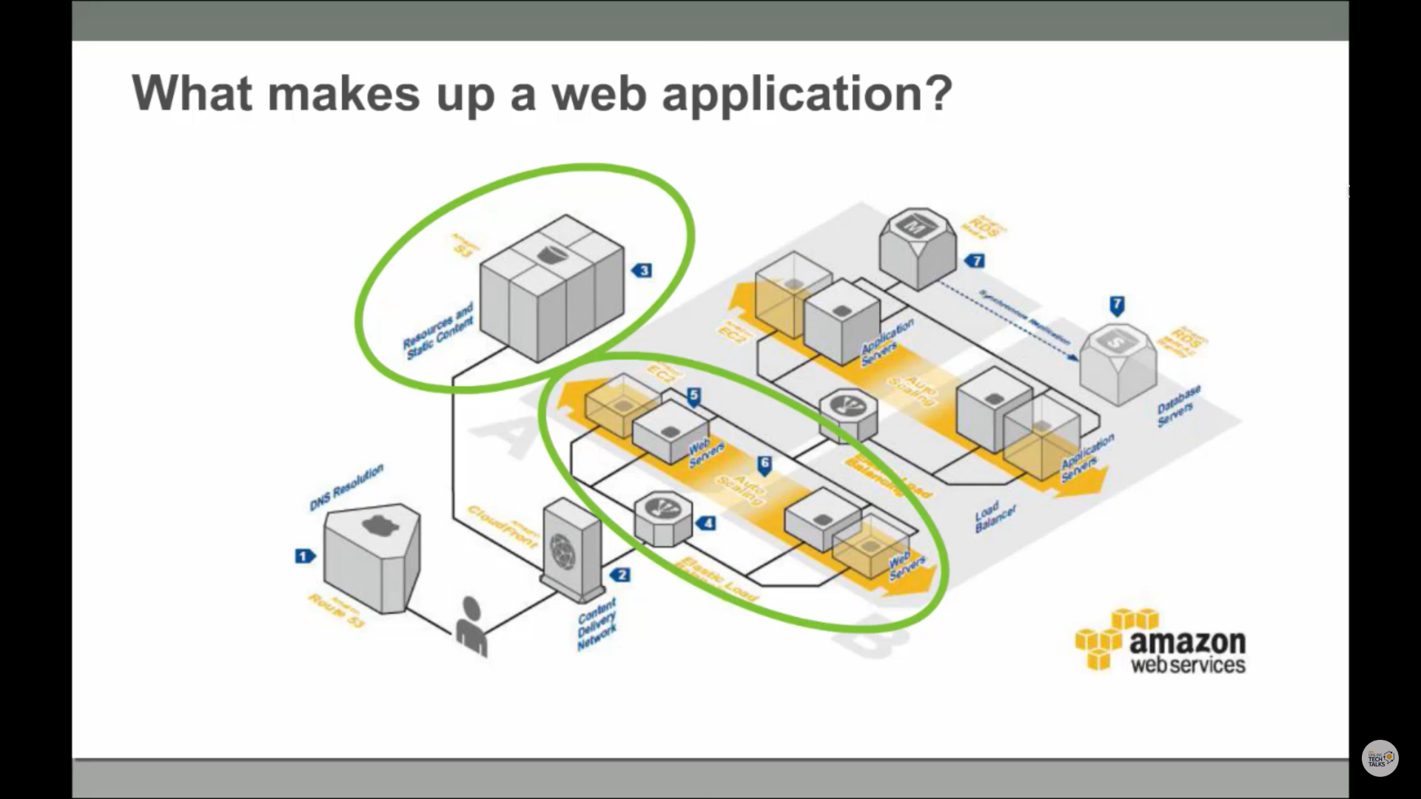

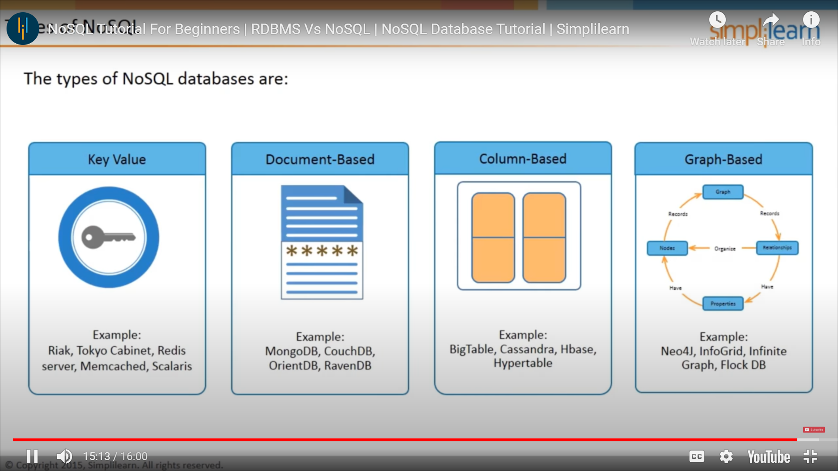

WEBINAR DETAILS:

Today I have attended the webinar on “General talk on C language-Introduction, Data types, Input/output and operators” by Assistant professor Ms. Megha D.Hegde, CSE department- AIET. The session was very interesting. There was assessment conducted based on the webinar. The test was of MCQ type, there were 15 number of questions of ONE mark each out of which I scored 11.

